03/Jun/2024

Import Control System 2 (ICS2) release 3 Onboarding Guide

Dear Valued Customer,
We would like to share an update on the upcoming Import Control System 2 regulations as a follow up to our previous communication sent on 8th May 2024 which can be Read here
We are pleased to inform you that Maersk becomes the first carrier to complete the mandatory Conformance testing of European Commission as confirmed by European Union Support desk. This was a critical milestone for the implementation of these regulations.
The new Advance Manifest Regulations deployment window for the Carriers starts between 3rd June 2024 and extends up to 4th December 2024. We will communicate our exact go live date in our next communication.
With reference to our earlier communication, we would like to guide you on the newly introduced data elements and below are the detailed steps required to be performed while submitting shipping instructions via different channels – Maersk.com / Inttra / EDI
- Does this shipment have a House Bill of Lading (HBL)?

As per the ICS2 regulations, if a forwarder is involved in a shipment, then it is mandatory to provide House bill of lading information to European Customs.
In case you are using Maersk.com for submitting the shipping instructions, please follow the below instructions for informing the involvement of house bill of lading. This field is already enabled on 3rd June 2024.
- If the House bill (Forwarder) is involved in a shipment, then kindly select the radio button as “Yes”
- In the House bill (Forwarder) is not involved in a shipment, then kindly select the radio button as “No”
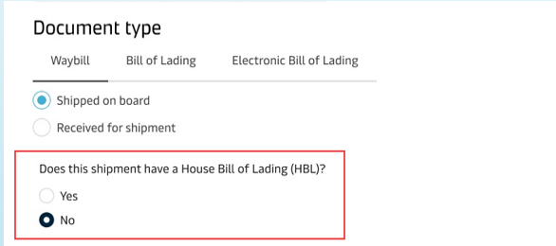
In case you are using Inttra for submitting the shipping instructions, you can use -
- If the House bill (Forwarder) involved in a shipment, then kindly select the radio button as “One House Bill” or “Multiple House Bills” basis the number of end house shipper or consignee involved in the shipment.
- If the House bill (Forwarder) is not involved in a shipment, then kindly select the radio button as “No House Bill”
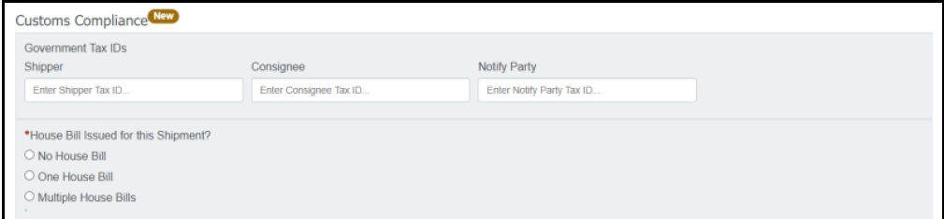
In case you are using EDI for submitting the shipping instructions, you can provide Key words for informing whether a House bill of lading involved.
- If the If the House bill (Forwarder) is involved in a shipment, then kindly use the key words such as “AMS” or “HBL” or “NVOCC”
- In the If the House bill (Forwarder) is not involved in a shipment, then there is no need to use any key words.
Important Note – The House bill are required to be provided only from 4th December 2024. The new HBL forms will be enabled at a later stage.

- EORI of the Next Filing Party (Supplementary Declarant)
Economic Operators Registration and Identification (EORI) number is assigned when you register your company as an importer or exporter in the European Customs Union.

- In case you are a forwarder and want to submit house bill of lading directly with European Customs (self-filing) then you are required to provide the EORI number of the company who will do this self-filing.
- In case you are a direct customer with the shipment involving Buyer and Seller (different than Shipper and Consignee on bill of lading) and you wish to provide this Buyer and Seller information directly with European Customs (self-filing) then you are required to provide the EORI number of the company who will do this self-filing.
In case you are using Maersk.com for submitting the shipping instructions, please follow the below instructions for informing the involvement of house bill of lading. This field is already enabled on 3rd June 2024.
Enter the EORI number of the party responsible for Self-filing in the below section -
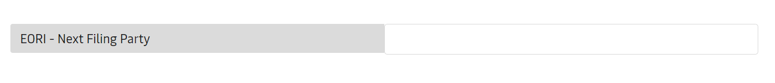
In case you are using Inttra for submitting the shipping instructions, you can use the below field to provide the EORI of the company responsible for self-filing.

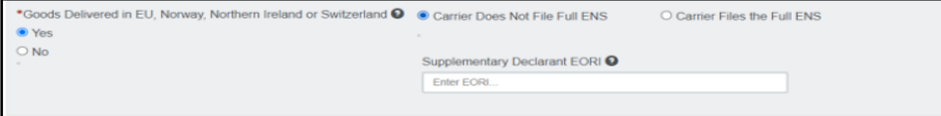
In case you are using EDI channel for submitting shipping instructions, you can provide the EORI of the of the company responsible for self-filing in the “Additional Remarks” section by using the key words “EORI Next Filing Party” or “EORI Supplementary Declarant.”
We will be enabling the new fields to provide “Buyer” and “Seller” information in our next release and will share an update once these fields are enabled from our end.

Best regards,
Maersk

