Maersk Customs Services
- What Customs Services are offered?
Import:
- Final Customs Declaration Standard Procedure - Direct power of attorney
    - VAT & duty paid before container release or
    - VAT & duty paid up to 5 days after import clearance (on request, Maersk Customs Services credit used)
- Final Customs Declaration Standard Procedure + 33a article - Direct power of attorney
    - Duty paid before container release or
    - Duty secured up to 5 days after import clearance (on request, Maersk Customs Services credit used)
    - VAT settled with VAT-7 declaration/JPK
    - Confirmation by Maersk Customs Services + signed contract required
    - Certificate of non-arrears at ZUS (The Social Insurance Institution in Poland) and US (PL Tax office) provided from above authorities (not written by customer)
- Phytosanitary services at port
- T1
- Final Customs Declaration Simplified Procedure – on request, please contact Maersk Representative
Consultancy, duty and VAT optimization, HS CODE classification
- On request
Conditions:
- T1 needs to be combined with Maersk transportation.
- Maersk Customs Services offer is not valid for excise nor military goods, private person as exporter or importer, mixed type of goods such as: used refrigerators and freezers, used tires, used cars, used car parts, used computers and used computer screens, used flat screen TV
Maersk Customs Services offer does not apply to services involving countries subject to any United Nations, European Union, United Kingdom or United States of America sanctions and export controls applicable to goods, services, persons involve, whether directly or indirectly, any entity or person identified, or owned or controlled by any such entity or person identified, on any list of individuals or entities with whom transactions are currently prohibited or restricted by any Sanctions.
- What is needed to start cooperation?
- PL VAT (obligatory) – not needed for T1
- EU EORI (obligatory)
- PL Tax identification number (obligatory for foreign companies)
- Power of Attorney (POA) - Original signed and stamped needs to be sent to MCS office before first clearance – E-Signature is also allowed (no need to send physical document then)
- POA has to be signed by a person appearing in the company’s commercial register (National Court Register (KRS), Chamber of Commerce) or by persons authorized to represent the company (proxy):
  - Office address: MLOG AGENCJA CELNA Sp. z o.o. ul. Gorskiego 3 Tower A, 7 floor, 81-304 Gdynia
  - Validity of Power of attorney: temporary or permanent:
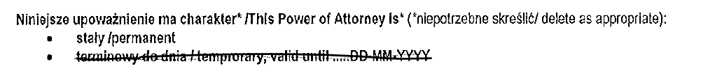
  - The person’s signature must match the company’s registration documents.
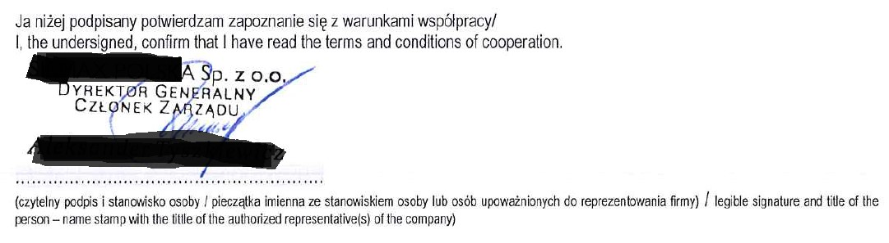
  - E-Signature is also allowed
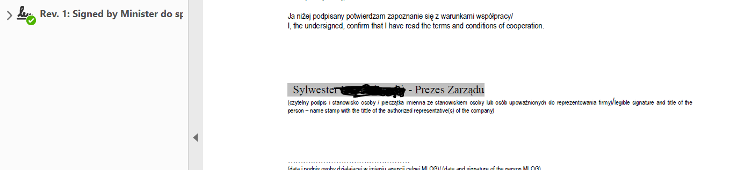

- Copy of confirmation of payment of stamp duty in the amount of 17,- PLN. to bank account:
Manually signed Power of attorney:
Urząd Miasta Poznania Wydział Finansowy, Oddział Dochodów Budżetowych, 61-706 Poznań, ul. Libelta 16/20,
Konto bankowe/ bank account: PKO Bank Polski S.A. Nr 94 1020 4027 0000 1602 1262 0763
BIC/SWIFT: BPKOPLPW; IBAN: PL
Digitally signed Power of attorney:
- Exporter/Importer with a registered office address in Poland :

To the tax authority (commune head, mayor, president of the city) competent for the address of the principal's registered office.
- Exporter/Importer with a registered office address outside of Poland:
Urząd Miasta Stołecznego Warszawy Centrum Obsługi Podatnika, NIP 525-22-48-481
Nr: 21 1030 1508 0000 0005 5000 0070
Nr: SWIFT: CITIPLPX
Nr: IBAN PL 21 1030 1508 0000 0005 5000 0070Payment title: Oplata skarbowa do upoważnienia MLOG Agencja Celna
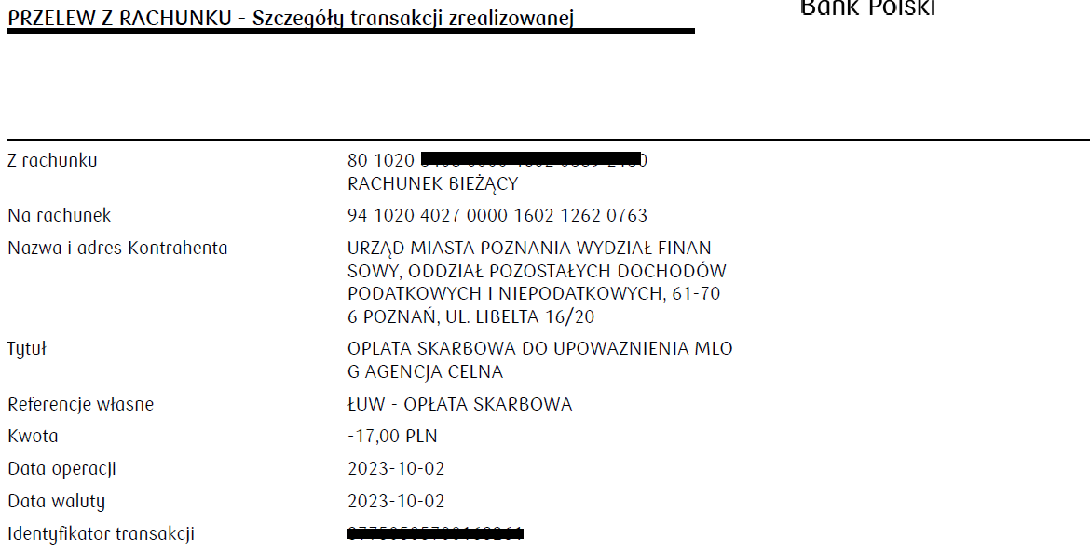
MLOG Customs Agency can make the payment on behalf of the client and send it to the office for a fee of USD 20.

- Invoice containing: date and number, name of commodity, currency, amount, quantity, number of packages, country of origin (if no certificate of origin), the name and address of the shipper/exporter and importer, container number, terms of delivery
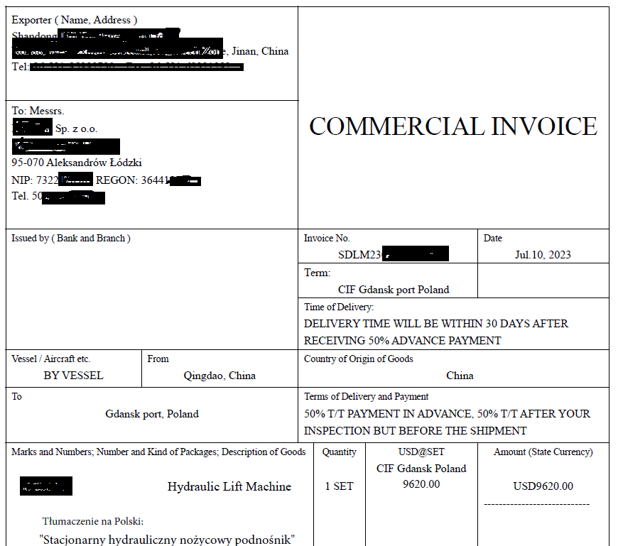
- Translation of shipped goods into Polish
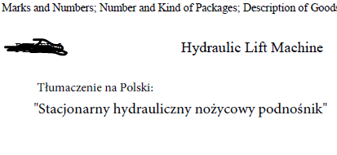
- Costs (freight, BAF, CAF, insurance, etc.). freight, BAF, CAF, insurance, etc.) if the terms of delivery are EXW, FOB, FCA, FAS
- HS Codes of transported goods

- Packing list with net and gross weight, quantity, number of packages and cartons or pallets, container number
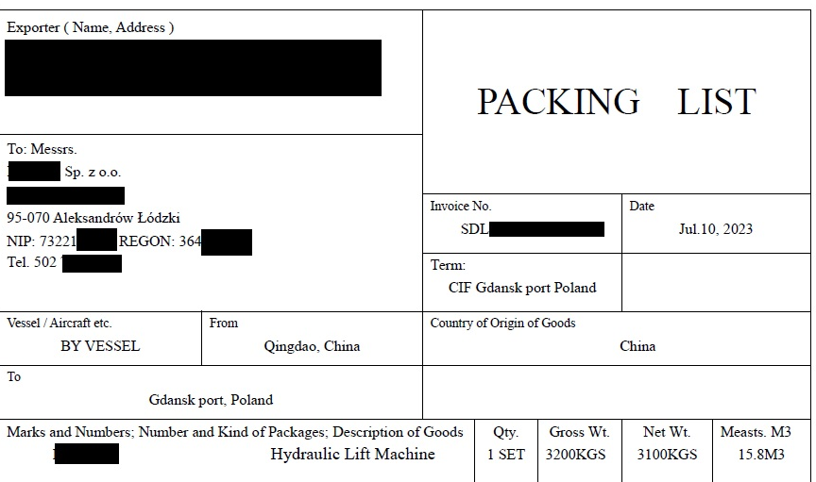
- B/L
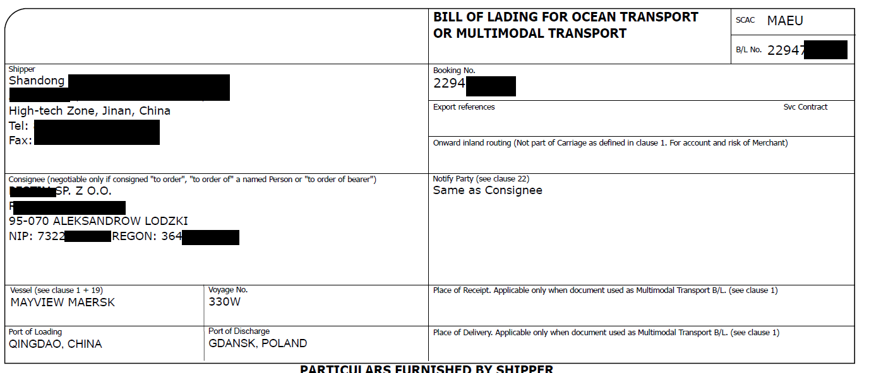
- Certificate of Origin (if needed)
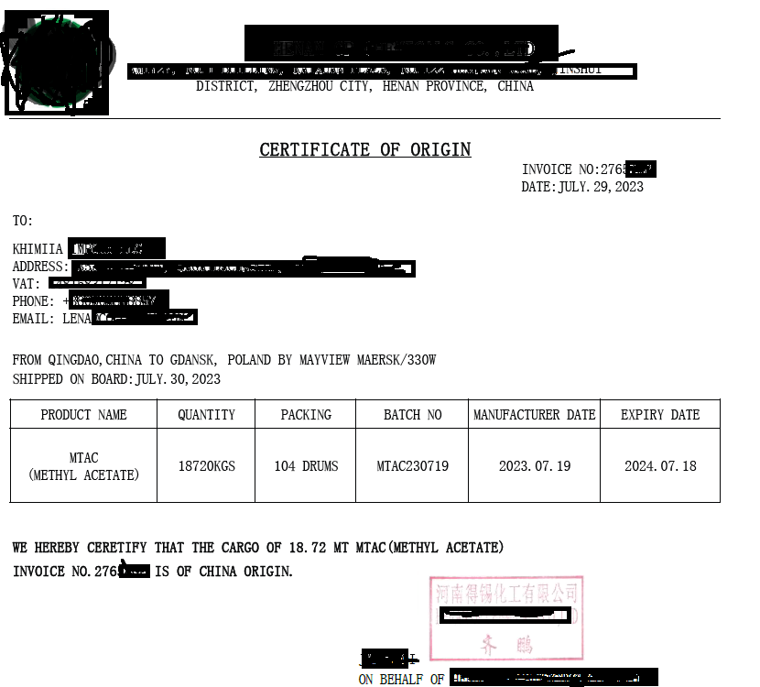
- Declaration of conformity (CE) (if needed)
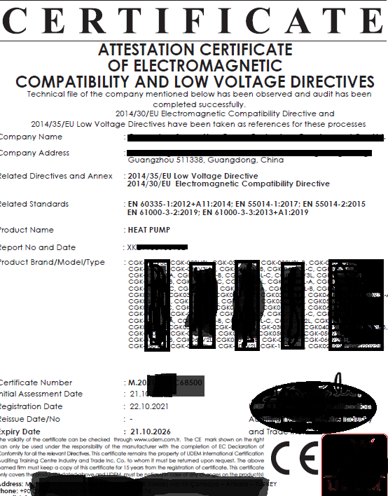
- Additional documents and information
- If the goods are loaded on wooden pallets – the certificate from the Regional Inspectorate
of Plant Health and Seed Inspection (WIORiN) is needed. MCS can arrange that.
- Importer is obliged to provide BTI (Biding Tariff Information) [WIT] and/or BOI (Binding Origin Information) [WIP] if there are any.
- If the goods are subject to CBAM regulation - the customer is obliged to report these goods individually to the National Competent Authority (NCA) of the Member State in which the importer is established (Poland – to the National Balancing and Emission Management Centre (KOBIZE)). The Customs Agency is not responsible for submitting CBAM reports (the service may be offered additionally).
- Excel files If documentation is unusually large (more than 10 positions on invoice)

- Additional services – Power of Attorney:

- Sanitary Authority - Veterinary Authority

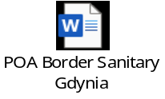

If you have any questions, please reach out to Maersk Representative

